To: Country X and Y

From: Gage Clawson and Juan Silva

Date: June 6, 2019

Re: Recommendations for reducing carbon emissions.

**BACKGROUND**

The Paris Accord has set goals to reduce carbon emissions around the world. This memo provides recommendations regarding proposals for a cap on carbon, a carbon tax, and a cap and trade policy in Country X. It also provides recommendations to Country X and Country Y for the possible implementation of an international carbon cap and trade policy, although Country Y is not held to the goals of the Paris Accord. Regarding these proposed policies, Country X and Country Y should take into consideration:

* Costs of meeting carbon targets in each country.
* Benefits of meeting the carbon targets in each country.
* Possible tax revenue generated from a tax policy.
* Cap and trade dynamics within and across countries.

**METHODOLOGY**

Data regarding carbon abatement levels and marginal costs in Sectors A, B, and C, in Country X, as well as Sector D in Country Y were analyzed to determine demand for emissions and marginal cost curves for each sector. The marginal cost and benefit curves were determined through the use of linear regression models. All assumptions and corresponding calculations (dollar values and abatement/emission units) can be found in the Technical Appendix.

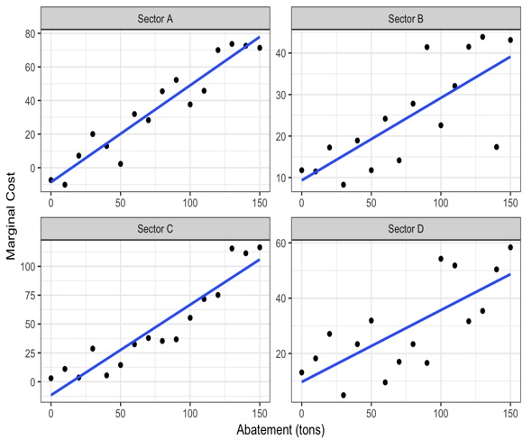**ANALYSIS**

Our analysis of policies in country X concluded that either a tax or an intra-country cap and trade result in nearly the same amounts of net social benefits to the country, with values of $18,272.12 and $18,271.9 respectively. Compared to only a carbon cap policy, a tax or cap and trade policy result in greater benefits overall for Country X. Regarding international cap and trade policy between Country X and Country Y, incentives are in place for Country Y to join the Carbon market in Country X. Country Y can sell enough permits to cover the costs of any abatement costs they may incur, as their cost for abatement is generally lower than that of sectors in Country X. There is possibility for Country X to meet the Paris Accord and their abatement goals at a cheaper price in a cap and trade market with Country Y. Country X participating in a carbon cap and trade policy with Country Y results in a greater net social benefit than using only intra-country policies.

**Figure 1. Marginal Cost of Abatement Curves**

**RECOMMENDATIONS**

Our analysis regarding policy options for intra-country policies in Country X concluded

that either a tax or cap and trade program will result in the same amount of benefits for the

country overall. However, if Country Y is willing to voluntarily enroll in an international cap and

trade program with Country X, Country X will receive greater benefits than any intra-country

policies, and should consider an international cap and trade of carbon to be their best option of

abatement.

**TECHNICAL APPENDIX**

**Question 1: Marginal Costs of Abatement**

**Marginal Cost of Abatement Functions:**

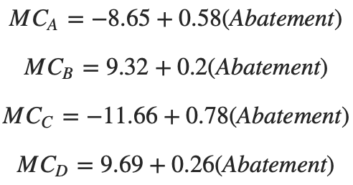

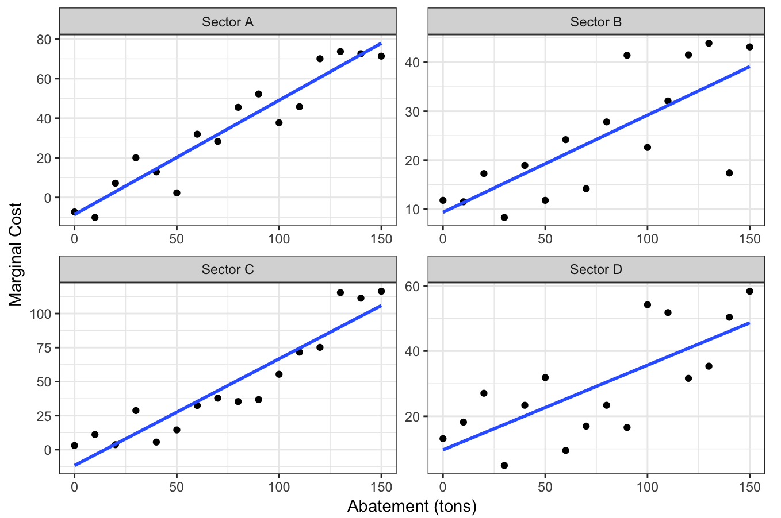

**Figure 1. Marginal Cost of Abatement Curves**

**Model fit:** The models for Sectors A and C have the best fit for the data. The model for Sector A fits the data with R2 = 0.9104. The model for Sector B fits the data with R2 = 0.5664. The model for Sector C fits the data with R2 = 0.8752. The model for Sector D fits the data with R2 = 0.5434.

2. Demand for Carbon Emissions

**Question 2: Demand for Emission Functions:**

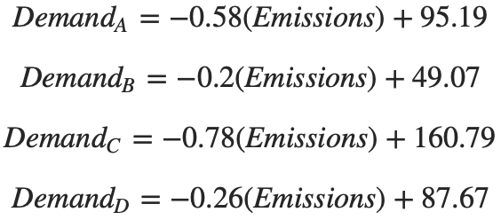

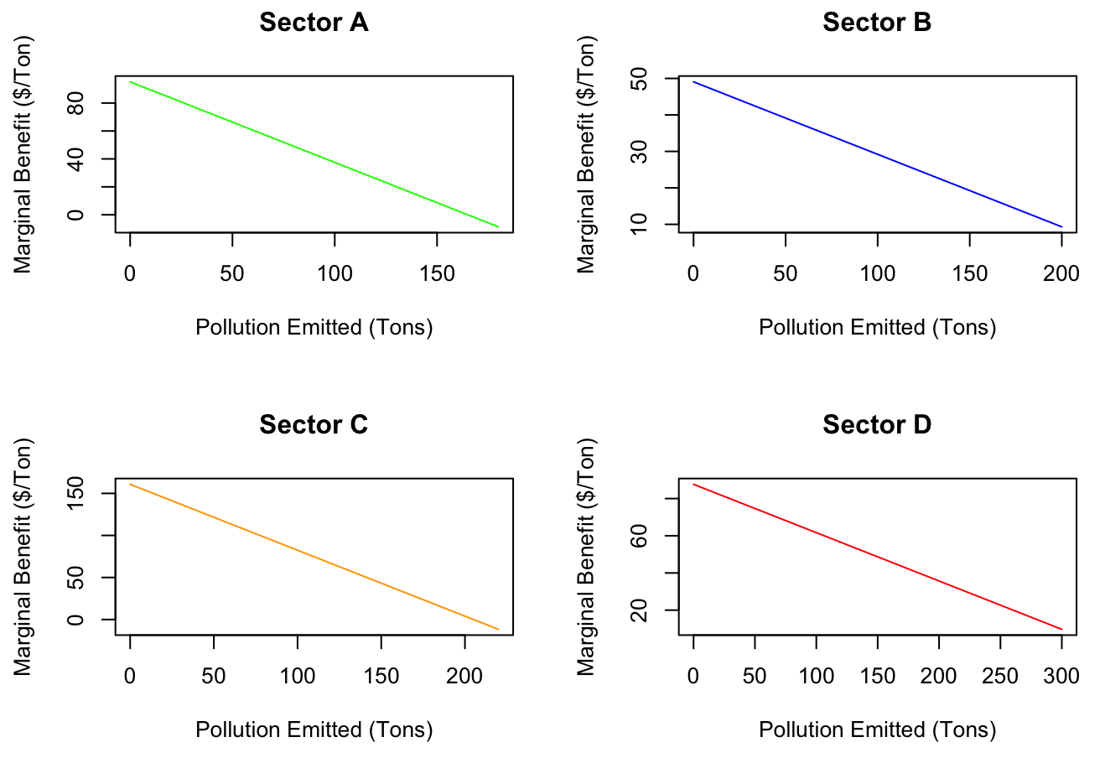

**Figure 2. Demand Curves for Carbon Emissions.**

* Sector C is willing to pay the most for the first unit of carbon emissions, $160.7868 per Ton.

**Question 3a: Cap on Carbon.**

|  |  |  |  |  |
| --- | --- | --- | --- | --- |
|  | **Sector A** | **Sector B** | **Sector C** | **Totals** |
| **Units Abated (Tons)** | 100 | 100 | 100 | 300 |
| **Abatement Costs** | $2019.76 | $1925.49 | $2753.63 | $6698.88 |
| **Units Polluted (Tons)** | 80 | 100 | 120 | 300 |
| **Pollution Benefits** | $5769.07 | $3912.93 | $13650.87 | $23332.87 |

**Figure 3. Table summarizing costs and benefits of implementing a cap on Carbon policy in Country X.**

1. Total cost of meeting the target in Country X: $6698.88
2. Abatement costs: A = $2019.76, B = $1925.49, C = $2753.63. Pollution benefits: A = $5769.07, $3912.93, $13650.87.
3. There is no tax, thus, no tax revenue.

**Question 3b: Tax on Carbon.**

|  |  |  |  |  |
| --- | --- | --- | --- | --- |
|  | **Sector A** | **Sector B** | **Sector C** | **Totals** |
| **Units Abated (Tons)** | 83.33 | 151.49 | 65.16 | 300 |
| **Abatement Costs** | $1282.61 | $3692.27 | $904.93 | $5879.81 |
| **Units Polluted (Tons)** | 96.66 | 48.50 | 154.83 | 300 |
| **Pollution Benefits** | $6506.22 | $2146.15 | $15499.57 | $24151.94 |
| **Tax** | $39.42 | $39.42 | $39.42 | $39.42 |
| **Tax Revenues** | $3811.18 | $1912.36 | $6104.44 | $11827.97 |
| **Tax Costs** | $3811.18 | $1912.36 | $6104.44 | $11827.97 |

**Figure 4. Table summarizing costs and benefits of implementing a tax on Carbon in Country X.**

1. Total cost of meeting the target with tax in Country X: $17707.78.
2. Abatement Costs: A = $1282.61, B = $3692.27, C = $904.93. Pollution Benefits: A = $6506.22, $2146.15, $15499.57. Tax Revenues: A = $3811.18, B = $1912.36, C = $6104.44.
3. Total tax revenue: $11827.97

**Question 3c: Cap and trade.**

|  |  |  |  |  |
| --- | --- | --- | --- | --- |
|  | **Sector A** | **Sector B** | **Sector C** | **Totals** |
| **Units Abated (Tons)** | 83.33 | 151.49 | 65.16 | 300 |
| **Abatement Costs** | $1282.61 | $3692.27 | $904.93 | $5879.81 |
| **Units Polluted (Tons)** | 96.66 | 48.50 | 154.83 | 300 |
| **Pollution Benefits** | $6506.22 | $2146.15 | $15499.57 | $24151.94 |
| **Permit Price** | $39.42 | $39.42 | $39.42 | $39.42 |
| **Permits Allocated** | 80 | 100 | 120 | 300 |
| **Permits Bought** | 16.66 | 0 | 34.83 | 51.49 |
| **Permits Sold** | 0 | 51.49 | 0 | 51.49 |
| **Permit Costs** | $657.05 | $0 | $1373.25 | $2030.29 |
| **Permit Revenues** | $0 | $2030.29 | $0 | $2030.29 |

**Figure 5. Table summarizing the costs and benefits of implementing a cap and trade policy in Country X.**

1. Total cost of meeting the target with permits in Country X: $7910.11.
2. Costs: A = $1939.66, B = $3692.27, C = $2278.18. Benefits: A = $6506.22, B = $4176.44, c = $15499.57.
3. There is no tax, thus, no tax revenue.

**Question 4: International Cap and Trade**

|  |  |  |  |  |  |
| --- | --- | --- | --- | --- | --- |
|  | **Sector A** | **Sector B** | **Sector C** | **Sector D** | **Totals** |
| **Units Abated (Tons)** | 66.65 | 103.07 | 52.89 | 77.39 | 300 |
| **Abatement Costs** | $705.0993 | $2016.08 | $479.92 | $1528.0 | $4729.10 |
| **Units Polluted (Tons)** | 113.35 | 96.93 | 167.11 | 222.61 | 600 |
| **Pollution Benefits** | $7083.73 | $2146.15 | $15924.58 | $13074.99 | $39905.64 |
| **Permit Price** | $29.80 | $29.80 | $29.80 | $29.80 | $29.80 |
| **Permits Allocated** | 80 | 100 | 120 | 300 | 600 |
| **Permits Bought** | 33.35 | 0 | 47.11 | 0 | 80.46 |
| **Permits Sold** | 0 | 3.07 | 0 | 77.39 | 80.46 |
| **Permit Costs** | $993.89 | 0 | $1403.96 | 0 | 2397.85 |
| **Permit Revenues** | 0 | $91.53 | 0 | $2306.32 | 2397.75 |

**Figure 6. Table summarizing a cap and trade program between Country X sectors and Country Y Sectors.**

Are there any incentives for country Y to enter country X’s carbon market and to thus place a voluntary cap on its emissions?

* Yes. Incentives are in place for Country Y to join the Carbon market in Country X. Country Y can sell enough permits to cover the costs of any abatement costs they may incur, as their cost for abatement is generally lower than that of sectors in Country X.

Are there any incentives for country X to try to attract country Y into its market?

* Yes. There is possibility for Country X to meet the Paris Accord and their abatement goals at a cheaper price in a cap and trade market with Country Y. Country X participating in a carbon cap and trade policy with Country Y results in a greater net social benefit than using only intra-country policies.

**Question 5: Air Pollution in Countries X and Y**

In a carbon cap and trade market that only covers sectors in country X, how much local air pollution would you expect in country X? In country Y?

* Country X produces 300 Tons of air pollution.
* Country Y produces 300 Tons of air pollution.

If country Y enters the carbon market for country X (as in question 4 above), how much local pollution will there be in country X and country Y?

* Local pollution is equal to the amount of emission in each country.
* Country X produces 377.39 Tons of air pollution.
* Country Y produces 222.61 Tons of air pollution.

What advice can you give country X and country Y about the desirability of allowing international trade of carbon emissions credits?

* Country X: Engaging in international cap and trade will allow to Country X to meet their abatement goal of 300 units at a cheaper price than not engaging in international cap and trade. However, by buying permits to emit more, the country is polluting more locally. There are also costs that will come from purchasing permits to pollute more, which should be considered.
* Country Y: Engaging in international cap and trade will allow Country Y to sell enough permits to cover the costs of any abatement costs they may incur. They will also pollute less than they would otherwise.